

KAUNAS UNIVERSITY OF TECHNOLOGY

FACULTY OF INFORMATICS

T120B166 Development of Computer Games and Interactive Applications

*Drowning Bullets*

|  |
| --- |
| *IFZm-1, Emilija Kravčenko:* |
|  |
| Date: 2024*.04.09* |

Kaunas, 2024

Tables of Contents

Tables of Images 3

Table of Tables/functions 4

Description of Your Game 5

Laboratory work #1 6

List of tasks 6

Solution 6

Task #1. *Camera Movement* 6

Task #2. *Guns* 7

Task #3. *Ammo control* 9

Task #4. Monsters walking, attacking and dying 10

Task #5. Monsters dropping items after their death 12

Task #6. Picking up items 13

Task #7. Pause Menu 17

Task #8. Weapon Upgrade 18

Task #9. Monsters shooting at player 19

Task #10. Pickaxe and crystals 21

Task #11. Water and swimming 22

Task #12. Adding grass, rocks 25

Task #13. Music and sound effects 26

Defense 27

User's manual 30

Literature list 31

ANNEX 31

# **Tables of Images**

Figure 1. Camera Movement Screenshot 6

Figure 2. Gun and animation Screenshot 8

Figure 3. Rifle gun’s ammo Screenshot 9

Figure 4. Monster‘s punch animation 10

Figure 5. Monster‘s death animation 11

Figure 6. Spawned pickable items 12

Figure 7. Health drink 12

Figure 8. Weapon upgrade 13

Figure 9. Ammo Box 13

Figure 10. Player‘s scan area for pickable items 14

Figure 11. UI label for picked up health drinks and weapon upgrades 15

Figure 12. UI label for picked up health drinks and weapon upgrades (2) 16

Figure 13. Paused game screen 17

Figure 14. Arsenal scene 18

Figure 15 Arsenal scene (2) 19

Figure 16. Monster shooting at player 20

Figure 17. Monster‘s attack beam particle effect 20

Figure 18. Pickaxe and crystal 22

Figure 19. Lake view when floating 23

Figure 20. Underwater view 23

Figure 21. Proton scatter plugin used for generating grass and rocks 25

Figure 22. Added grass model and shader visuals 26

Figure 23. Reload sound effect Figure 24. Music #2 Figure 25. Game over sound effect 26

Figure 27. Wave complete sound effect Figure 28. Music #1 Figure 29. Player shooting sound effect 26

Figure 30. Monster shooting sound effect Figure 31. Mining sound effect 26

Figure 32. Item pick up sound effect Figure 33. Monster attack sound effect 26

Figure 34. Upgrade sound effect 26

Figure 35. Player‘s damage on collision screenshot 28

Figure 36. Zoomed in sgame screen 29

# **Table of Tables/functions**

Table 1. Camera Movement Code 7

Table 2. Weapon Resource code 8

Table 3. Weapon Collision detection code 9

Table 4. Weapon Reload Code 10

Table 5. Monster‘s movement code 11

Table 6. Monster‘s distance to player calculation 12

Table 7. Item spawn code 13

Table 8. Player‘s pickable item scan code 16

Table 9. health drink‘s code 17

Table 10. Pause Menu code 18

Table 11. Arsenal‘s weapon‘s data upgrade code 19

Table 12. Monster‘s beam creation code 21

Table 13. Monster‘s attack with raycast code 21

Table 14. Crystal mining code 22

Table 15. Player‘s swimming code 24

Table 16. Water shader 24

Table 17. Underwater caustics shader 25

Table 18. Autoloaded music and sound control code 27

Table 19. Player‘s damage on collision code 27

Table 20. weapon zoom code 29

Table 21. Crosshair texture change code 30

# **Description of Your Game**

Description of Your Game.

1. 3D or 2D? 3D
2. What type is your game? First Person Looter Shooter
3. What genre is your game?Action Roguelike
4. Platforms (mobile, PC or both?) PC
5. Scenario Description. Pirmo asmens 3D roguelike šaudyklė. Žaidėjas pradeda žaidimą vandenyje. Link jo bėga priešai (monstrai). Veikėjas gali panerti po vandeniu. Ilgai panėrus paskęsta. Jei monstrai sužeidžia taip pat miršta. Turas pasibaigia kai žaidėjas nužudo visus priešus arba miršta. Tada žaidėjas gali pasirinkti ar kovoti toliau ar baigti žaidimą. Kiekvieną turą priešų vis daugėja ir jie stiprėja (turi daugiau gyvybių, suteikia daugiau žalos). Priešus nužudžius, jie palieka po savęs šaudmenis, gyvybių atstatymą arba, pagerinimus žaidėjo veikėjui arba žaidėjo ginklams. Pagerinimų kiekis yra neribotas ginklams ir veikėjui, jų galima prisidėti kiek norima.

**Laboratory work #1**

**List of tasks** (main functionality of your project)

1. Camera Movement
2. Guns
3. Ammo Control
4. Monsters walking, attacking, dying
5. Monsters dropping items after their death
6. Picking up items
7. Pause Menu
8. Weapon Upgrade
9. Monsters shooting at player
10. Pickaxe and crystals
11. Water and swimming
12. Adding grass, rocks
13. Music and sound effects

# **Solution**

## **Task #1. *Camera Movement***

Adding movement to character’s camera when player moves mouse. Moving the mouse changes what the player sees and the direction their character is looking at. Rotation to the side is unlimited, but looking up and down has fixed values.

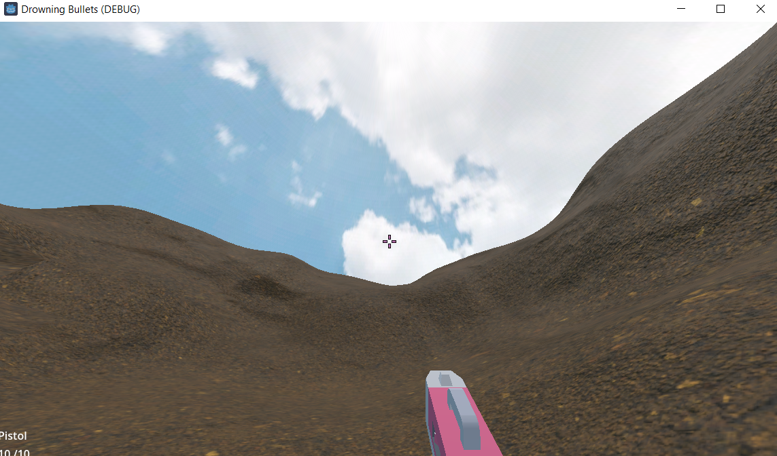

Figure 1. Camera Movement Screenshot

After mouse motion camera and character rotates towards that direction based on defined mouse sensitivity. Pressing Escape key cancels mouse tracking and displays mouse cursor.

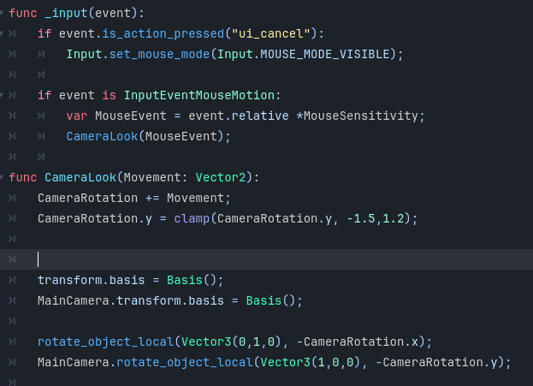

Table 1. Camera Movement Code

## **Task #2. *Guns***

Adding gun models. Creating animations for shooting reloading, changing weapon. Creating weapon resources. Adding ray cast to check if shot hit target.

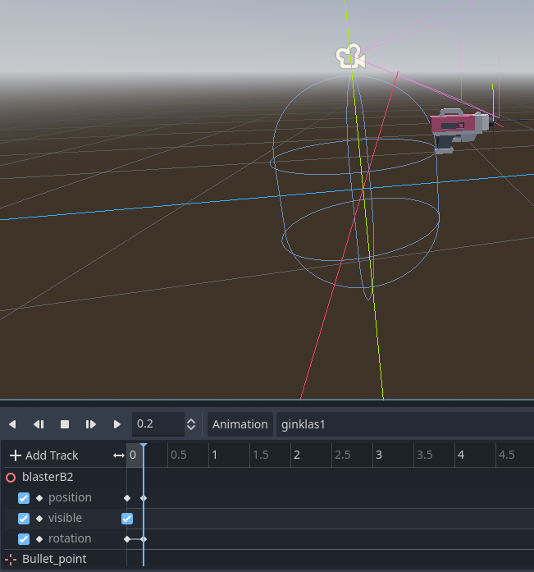

Figure 2. Gun and animation Screenshot

Weapon Resource is used to define weapon class, weapon variables to use on all guns.

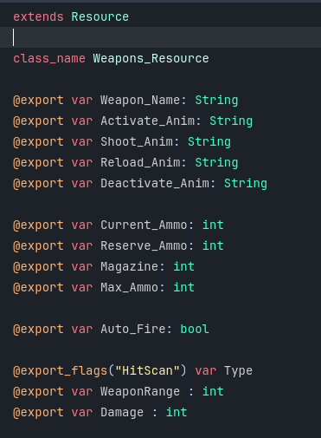

Table 2. Weapon Resource code

HitScanCollision calculates ray’s direction, end point, any collision that intersects with ray. On collision it displays Hit indicator – Bullet hole.

HitScanDamage checks if Ray cast from a gun points at an object in group “Target”. And sends variables of weapon damage, bullet’s direction and position where it hit target.

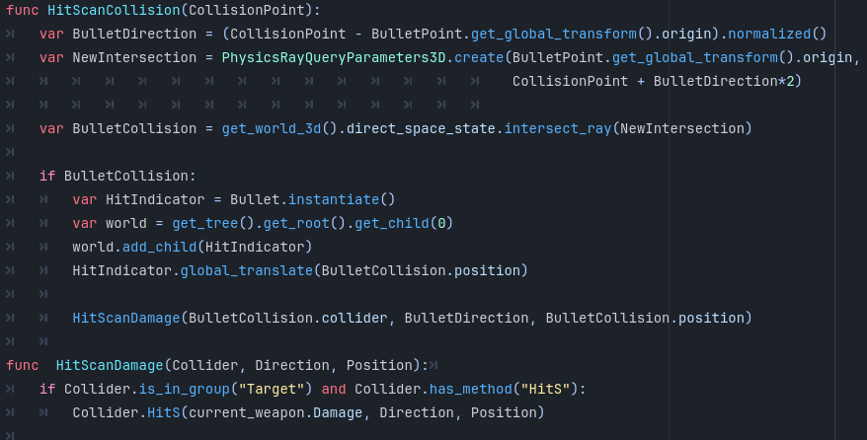

Table 3. Weapon Collision detection code

## **Task #3. *Ammo control***

Adding current ammo, magazine, reserve ammo and max ammo variables. These variables help to track and display each gun’s Ammo state and capacity. After reaching 0 ammo, weapon automatically reloads after “shooting” - pressing left mouse button. Player can also press “R” to reload at any time.

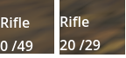

Figure 3. Rifle gun’s ammo Screenshot

When starting gun’s current ammo is gun’s full magazine ammo. On reloading it checks if the current ammo is full. If not, it calculates how much to take from ammo reserve and recalculates gun’s current and reserve ammo variables. At the end it sends signal to update gun’s variables.

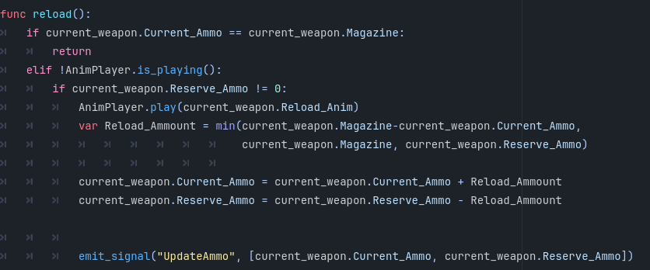

Table 4. Weapon Reload Code

## **Task #4. Monsters walking, attacking and dying**

Monsters walk/fly towards the player on predefined navigation mesh. After reaching a certain distance from the player they can punch the player, thus hurting them. If the player manages to kill them, they fall to the ground and disappear after a few seconds.

Monsters has three animations: walking, punching, and dying. Monsters interpolate between them based on their health and distance from their target – the player.

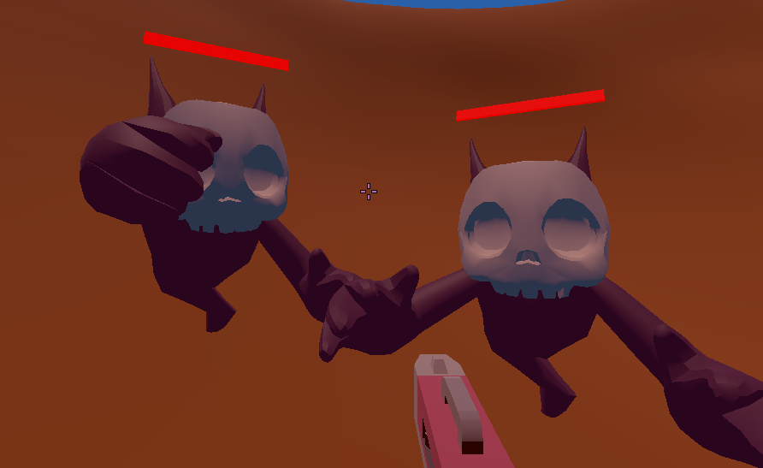

Figure 4. Monster‘s punch animation

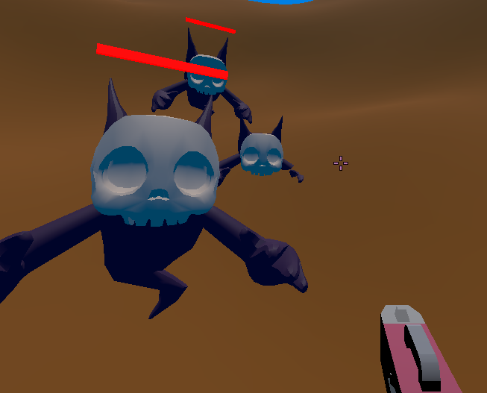

Figure 5. Monster‘s death animation

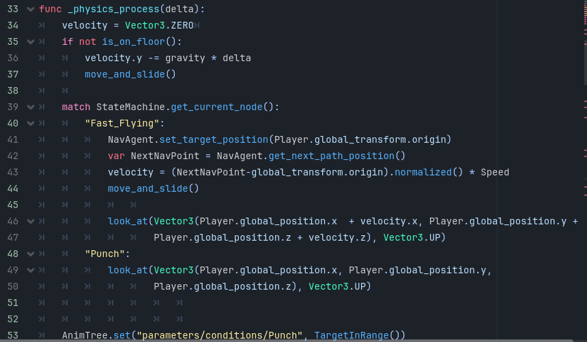

Table 5. Monster‘s movement code

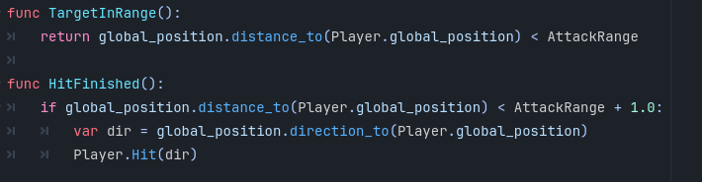

Table 6. Monster‘s distance to player calculation

## **Task #5. Monsters dropping items after their death**

## 

When the player kills any monster, after monster disappears three items are spawned on its death location. The dropped items are: health drink, random upgrade for a weapon and 10 bullets in a box.

Monster’s code initializes all spawnable items scenes and adds them to the scene before erasing killed monster’s scene from current scene.

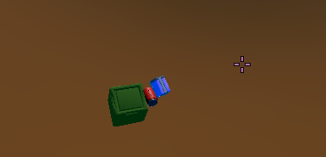

Figure 6. Spawned pickable items

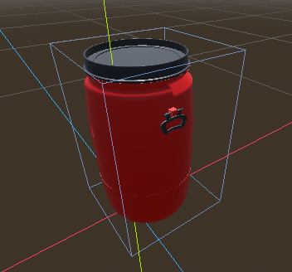

Figure 7. Health drink

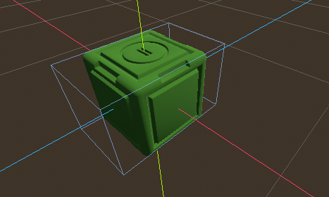

Figure 8. Weapon upgrade

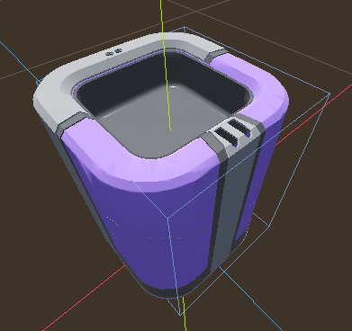

Figure 9. Ammo Box

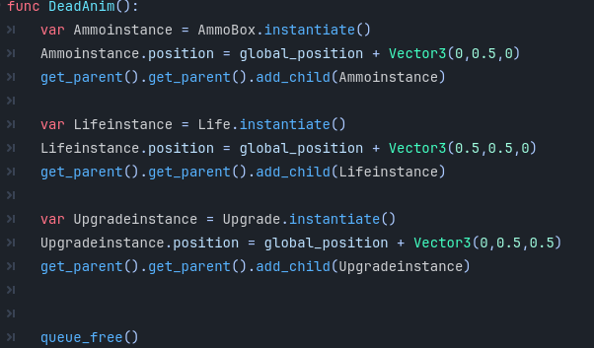

Table 7. Item spawn code

## **Task #6. Picking up items**

Player has sphere shaped area around them that scans for pickable objects that enter that area. This area does not interact with anything else and only calls a found item’s method, upon finding it. All pickable objects are placed in one layer and each one has a method “Collectable” that implements item’s functions and then removes it from a scene.

Item signals to player that it is collected and after receiving a signal player’s interface is updated, picked up item can be instantly used.

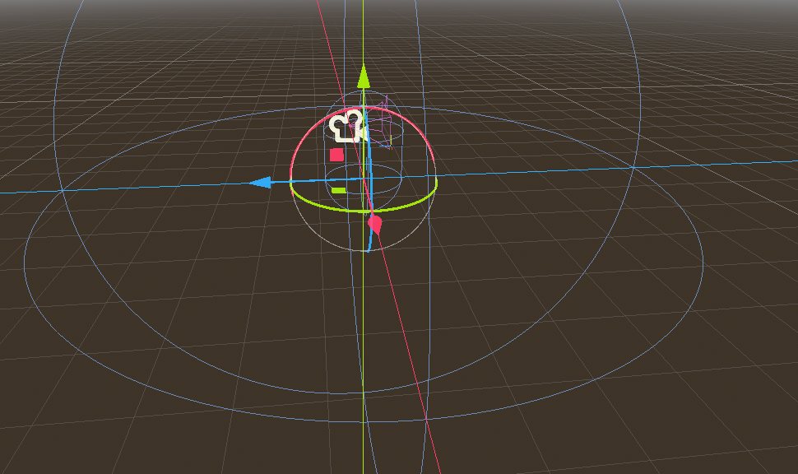

Figure 10. Player‘s scan area for pickable items

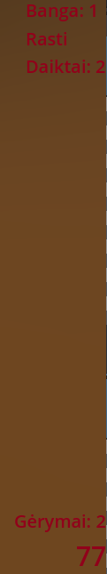

Figure 11. UI label for picked up health drinks and weapon upgrades

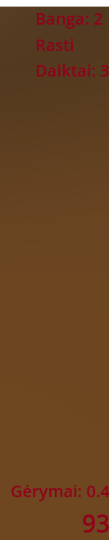

Figure 12. UI label for picked up health drinks and weapon upgrades (2)

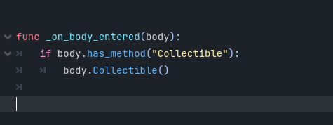

Table 8. Player‘s pickable item scan code

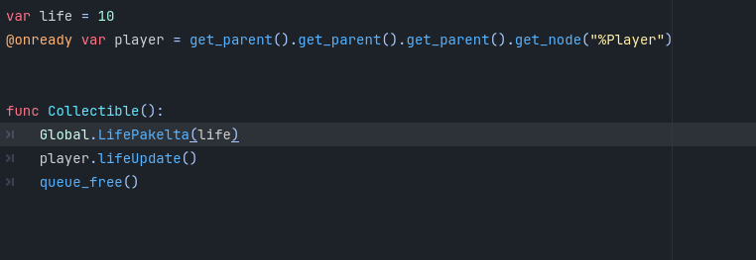

Table 9. health drink‘s code

## **Task #7. Pause Menu**

Pressing Esc key pauses the game and shows a pause menu. By clicking “Pasiduoti” button player can leave the game and go to the Main menu screen. Clicking Esc key again, removes pause screen and resumes the game.

Pausing the game causes all scripts connected to the game to wait for the game to be unpaused. Pause menu and its elements process actions and input only when the game process is paused.

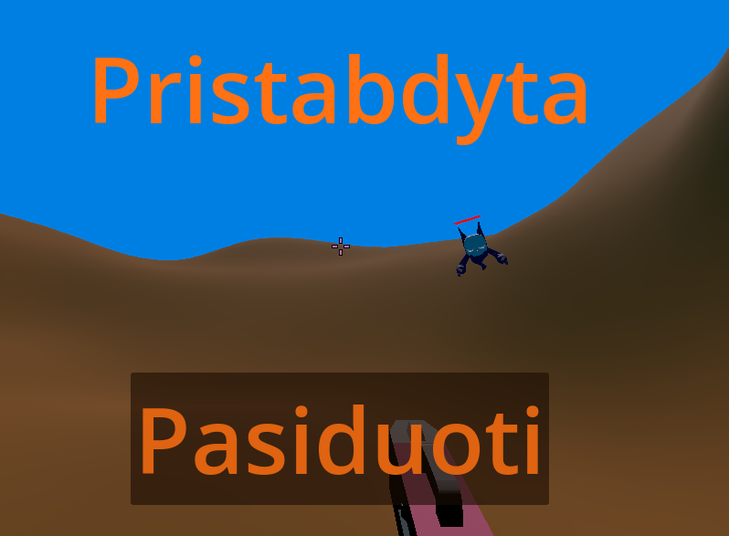

Figure 13. Paused game screen

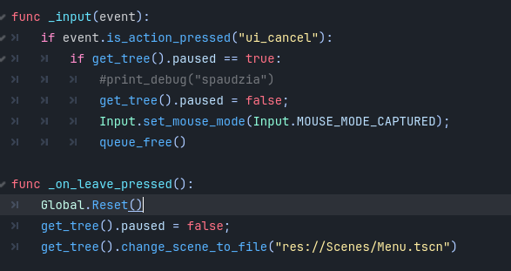

Table 10. Pause Menu code

## **Task #8. Weapon Upgrade**

If the player picks up weapon upgrades during the fight, all weapon upgrades appear in arsenal. Arsenal has two shelves. On the left one upgrades are displayed, on the right one, weapons and their data (damage, magazine size, ammo). After picking an upgrade and picking a weapon to upgrade, a player can press on the upgrade button in the middle to upgrade chosen weapon with a chosen upgrade.

All weapon data is stored in a weapon’s resource file. Picked up weapon upgrades are stored in a globally accessible file. After each upgrade files are updated and new values are used in fight scene.

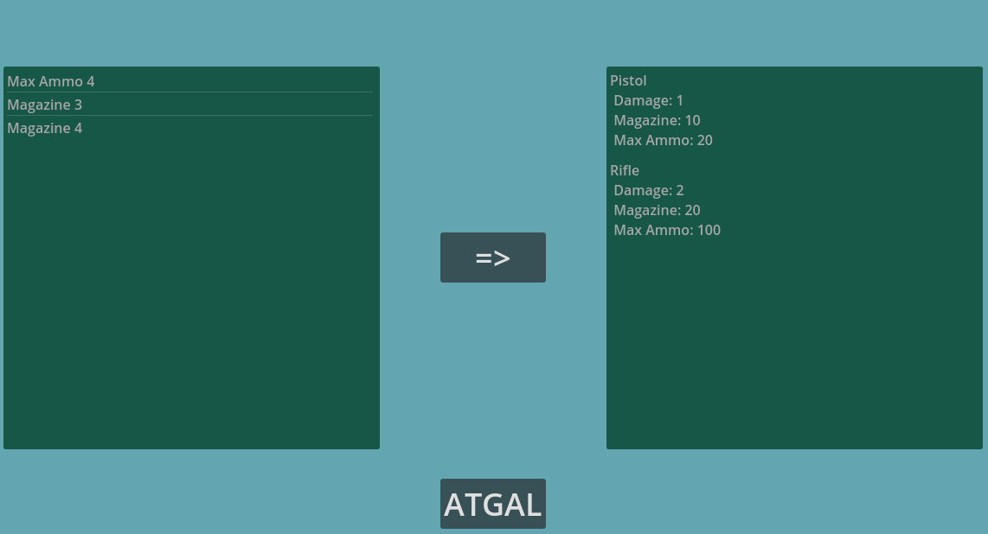

Figure 14. Arsenal scene

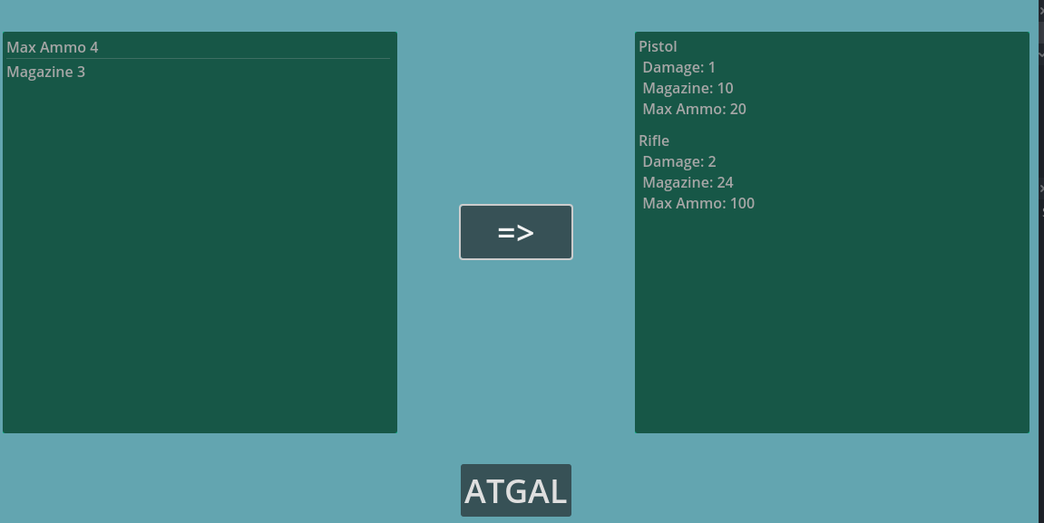

Figure 15 Arsenal scene (2)

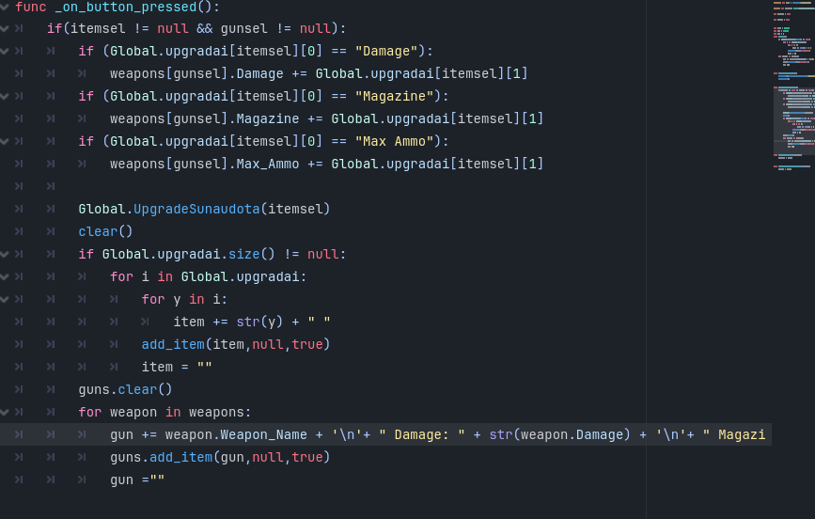

Table 11. Arsenal‘s weapon‘s data upgrade code

## **Task #9. Monsters shooting at player**

A green monster can shoot beams at player from a bigger distance than melee monsters punch. Green monsters walk slower and take longer to recharge their attacks. Monster only finishes beam attack if it can hurt player.

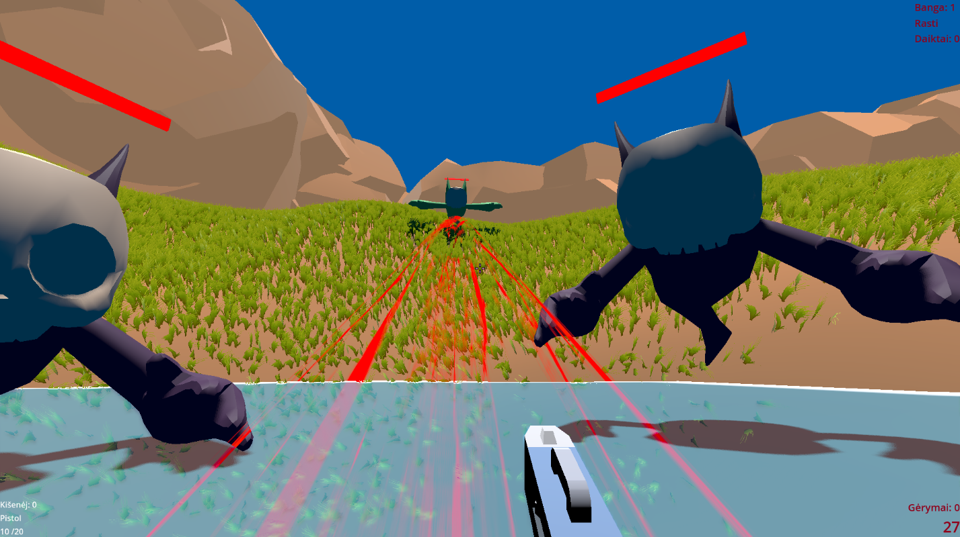

Figure 16. Monster shooting at player

Beam is created using raycast, particle and shader. Particle is used to make beam as long as the distance between monster and the player. Shader is used to create an effect of rotation and movement of the beam.

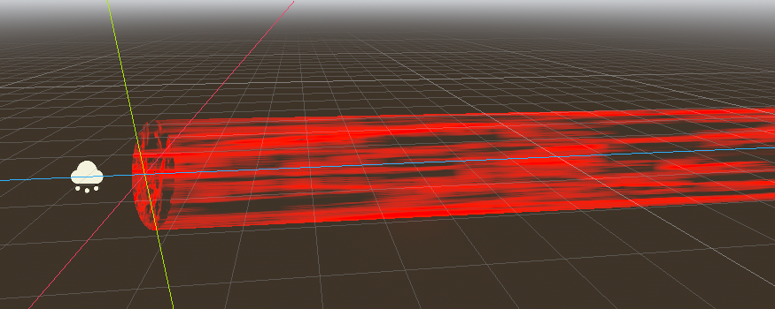

Figure 17. Monster‘s attack beam particle effect

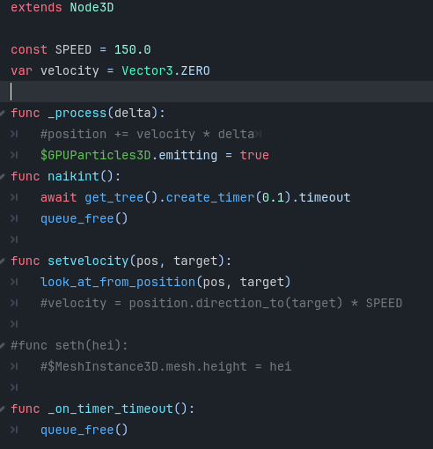

Table 12. Monster‘s beam creation code

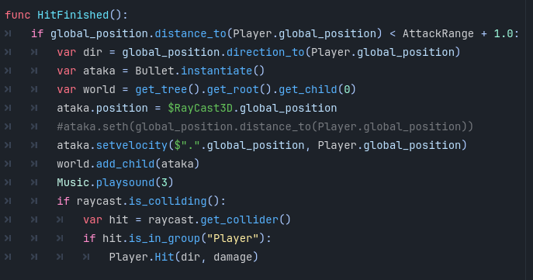

Table 13. Monster‘s attack with raycast code

## **Task #10. Pickaxe and crystals**

By pressing “c” player can take out a pickaxe. Pickaxe mining is done with left mouse button. Pickaxe can only mine crystals, that are underwater Crystals are spawned in four predefined locations as one of three colors (yellow, green, red) and respawn again after each wave if they were mined. Each crystal can be mined three times and give three small crystals, that then can be used in armory to upgrade character stats (Hp and Time that player can be underwater before drowning).

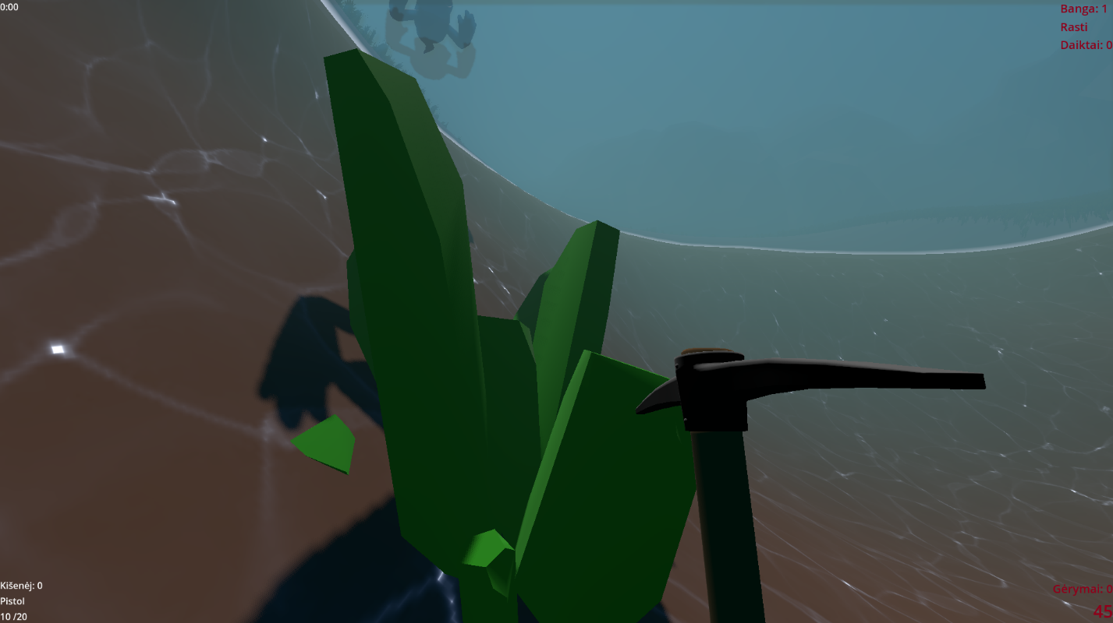

Figure 18. Pickaxe and crystal

Pickaxe hit is being animated and at the point it reaches the ground and crystals check if their area is colliding with pickaxe. After each successful hit with pickaxe on crystal it scales itself down 1/3 of its size before disappearing.

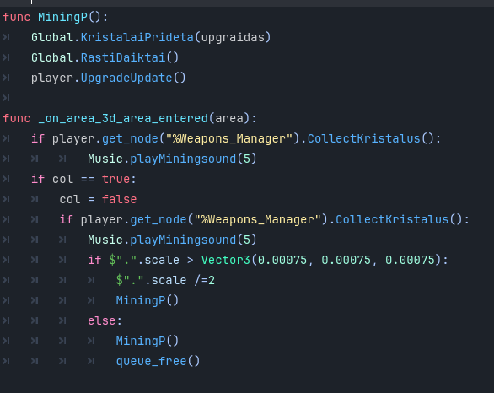

Table 14. Crystal mining code

## **Task #11. Water and swimming**

Player is always floating in the water or swimming underwater. After pressing “Shift” key if player is in the water, player is submerged underwater. Then player can move like when floating in the water, but also surge deeper down with “Shift” or go towards the surface with “Space”. Player can only stay underwater for some time before drowning begins. After going underwater a timer appears in the top left corner of the screen. After reaching zero player starts to drown until dying or reaching the surface for air.

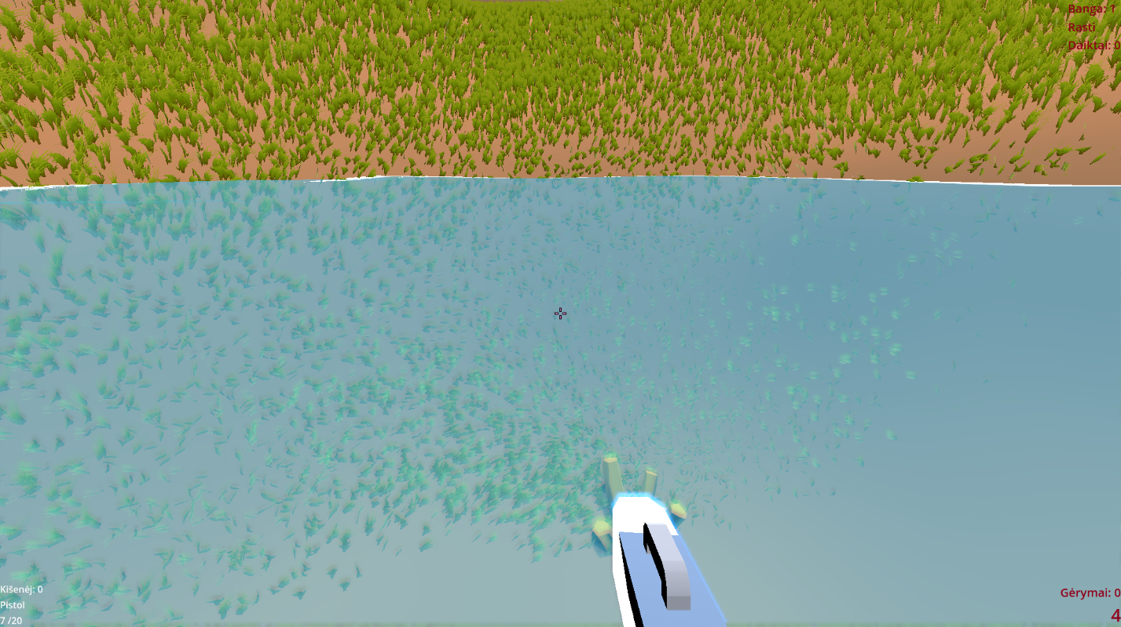

Figure 19. Lake view when floating

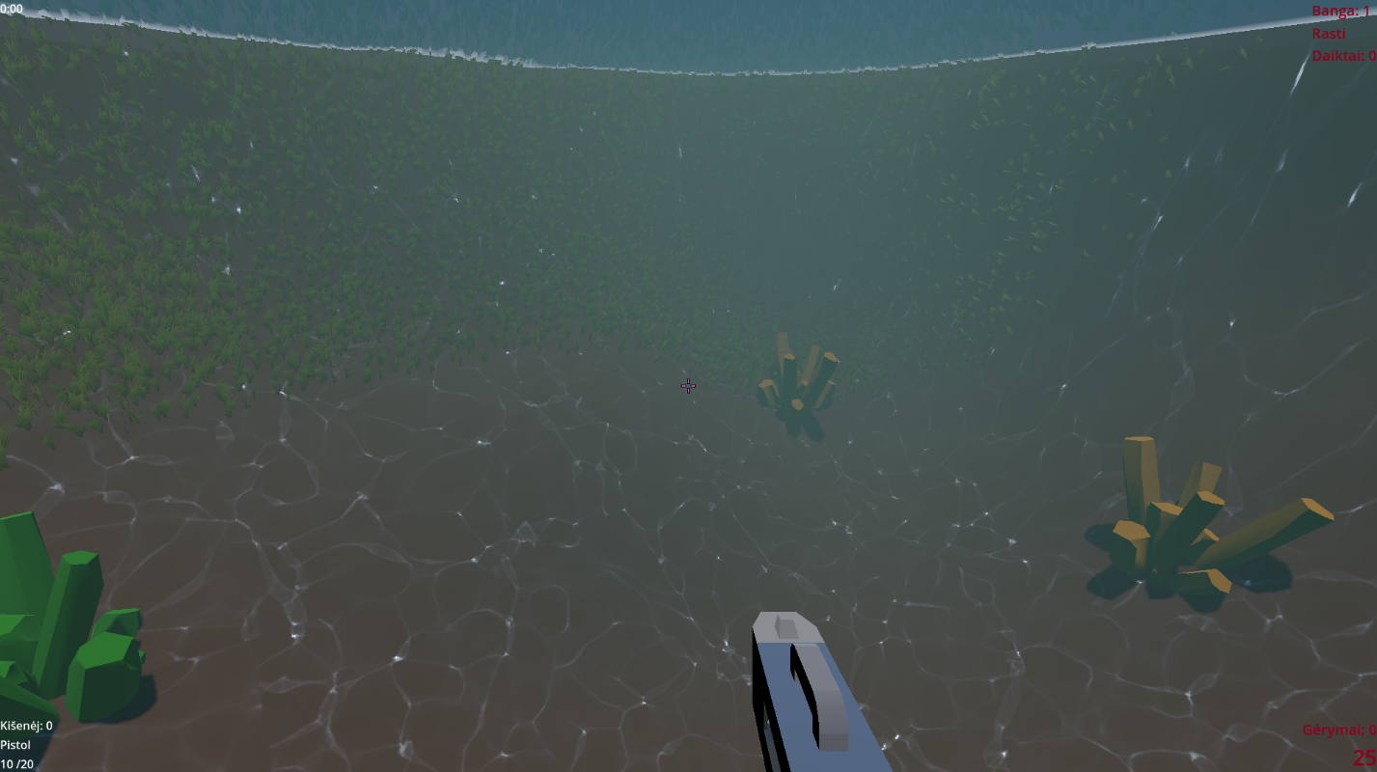

Figure 20. Underwater view

After going underwater, water’s collider for player is removed and player can shoot upwards. But once player’s raycast reaches water collider, it is no longer considered underwater and can now float. Pressing the same button (“Shift” or “Space”) increases the speed until reaching maximum possible speed. Pressing them once, one after the other, makes player float in one place.

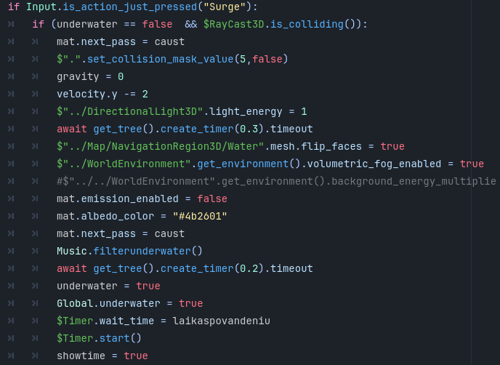

Table 15. Player‘s swimming code

Water is a simple plain mesh with a shader, that simulates three waves and creates foam around objects it touches. Material shader is taken from github and changed a little.

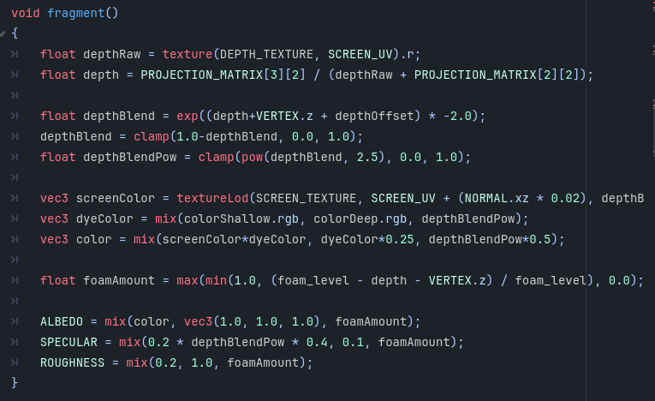

Table 16. Water shader

After going underwater environment becomes darker, fog appears ant caustic effect is displayed on the terrain underwater. Caustics effect is created from a texture and is moved over terrain material, but bellow water level.

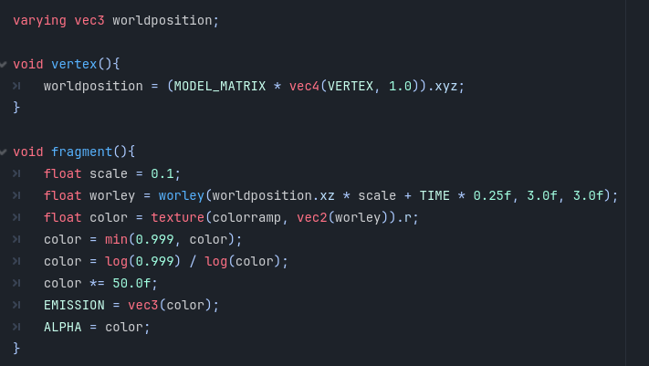

Table 17. Underwater caustics shader

## **Task #12. Adding grass, rocks**

A Godot plugin was used to create big area of grass and rock walls around lake. Grass and rock model used from plugin. In scatter node, after defining what amount of grass to generate, and its properties, the most optimal amount was 10 patches of 1000 grass models. A loading screen was created to wait for grass to be visualized, before starting the game. For rocks, only 4 patches of 20 large rocks were used, so it does not require intense processing.

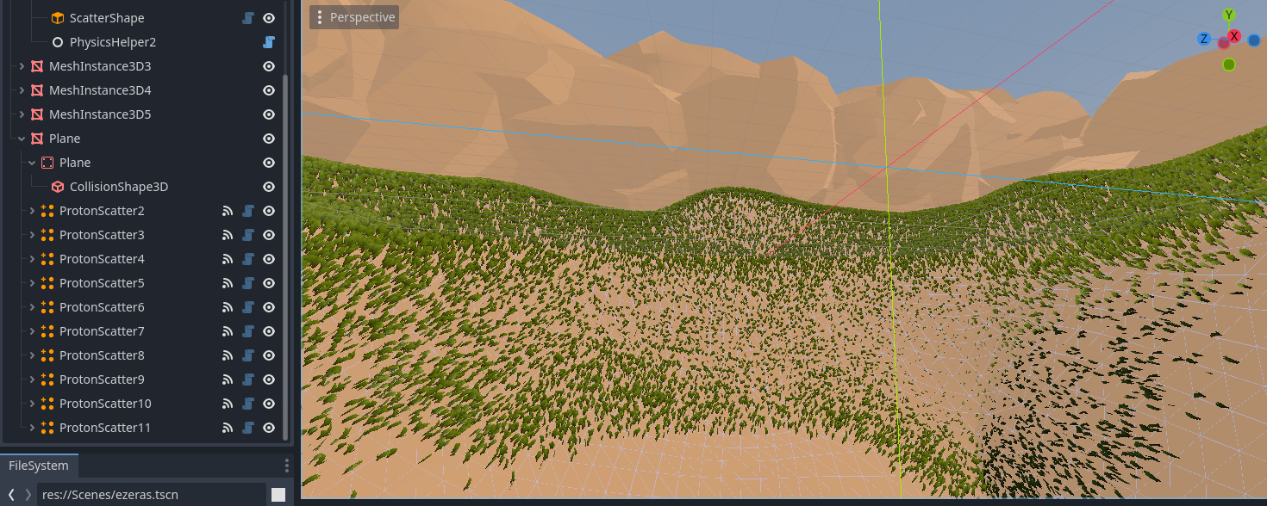

Figure 21. Proton scatter plugin used for generating grass and rocks

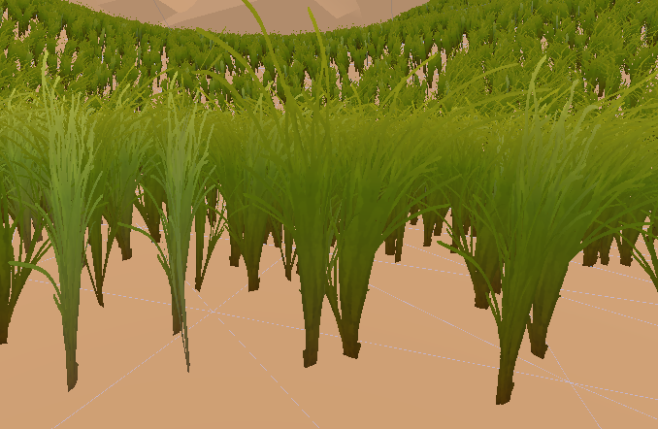

Figure 22. Added grass model and shader visuals

## **Task #13. Music and sound effects**

Two different music’s are played across the game. One, when the player is in main menu or Arsenal, another, when the player is fighting. In main menu player can also check off sound button to mute all sounds or use slide bar to adjust sound level.

  

Figure 23. Reload sound effect Figure 24. Music #2 Figure 25. Game over sound effect

  

Figure 27. Wave complete sound effect Figure 28. Music #1 Figure 29. Player shooting sound effect

 

Figure 30. Monster shooting sound effect Figure 31. Mining sound effect

 

Figure 32. Item pick up sound effect Figure 33. Monster attack sound effect



Figure 34. Upgrade sound effect

To play music continuously across scenes a single autoload scene was created with two sound players. One for music and one for sound effects. To music player, a low pass filter is applied when player is underwater to simulate effect. A sound effect is played whenever something happens. Player shoots, picks up items, is attacked, dies etc.

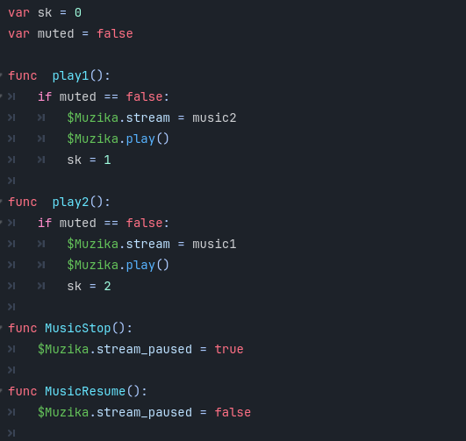

Table 18. Autoloaded music and sound control code

**Defense**

**Task: On player’s character’s collision with Monsters take damage.**

Solution:

When moving checks is collided object has method Hurt. If it does, the player takes one damage. And waits 1 second before checking if colliding with anything.

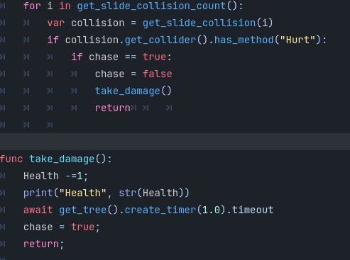

Table 19. Player‘s damage on collision code

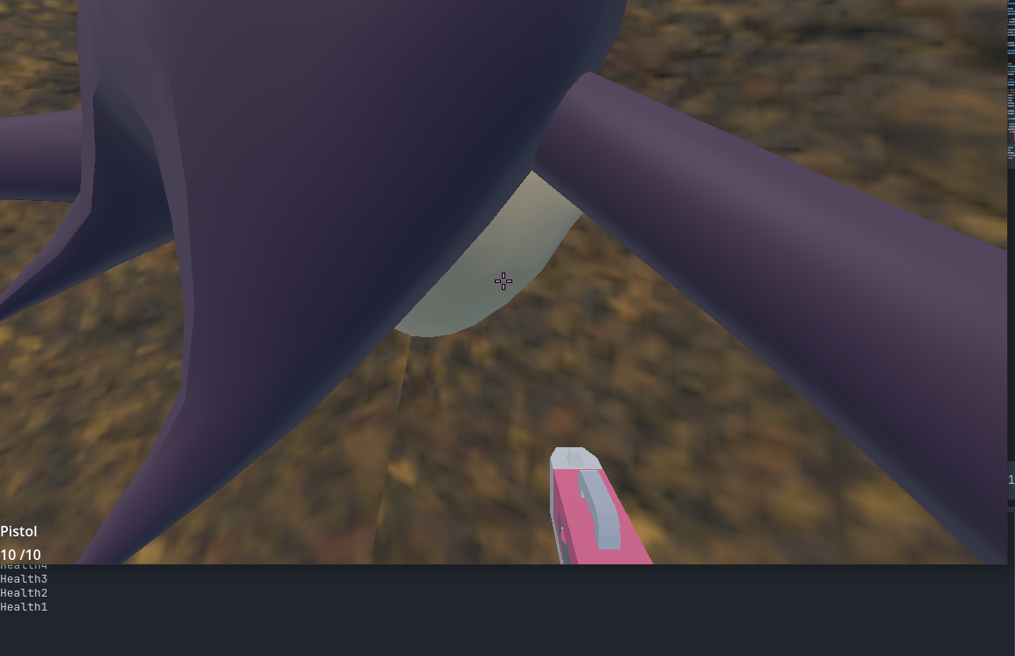

Figure 35. Player‘s damage on collision screenshot

**Task: When zooming position weapon so it is visible to player and make bigger crosshair**

Solution:

Creating animations for weapons and playing them when weapons are in zoom mode, chainging crosshair texture when pressing zoom button.

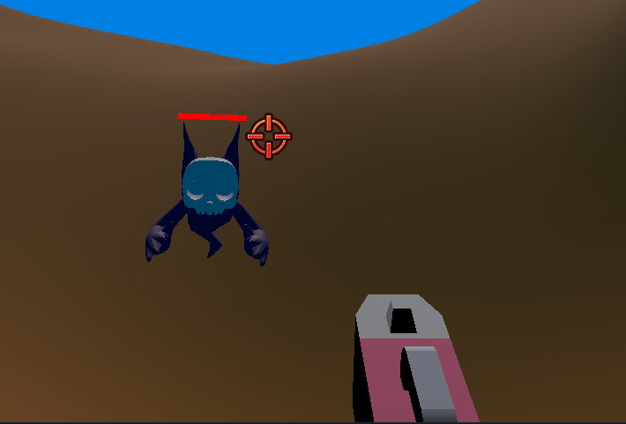

Figure 36. Zoomed in sgame screen

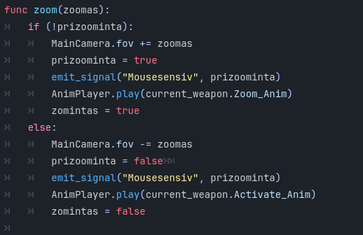

Table 20. weapon zoom code

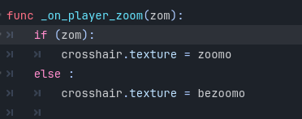

Table 21. Crosshair texture change code

**User's manual**

**How to play?** Shoot monsters and gather resources dropped from dead monsters or by mining crystals underwater. Use gathered resources to upgrade weapons, replenish health and ammo during fight. Avoid dying by taking too much damage or drowning.

**Descriptions of the rules of the game**. Kill all monsters and advance to next wave with more and stronger enemies or come back home to improve stats keeping the loot. Replay the waves as much as you want.

**Descriptions of the controls / keys.** Arrow keys moves character, mouse moves character’s camera. Shift makes player dive underwater. Spacebar makes character jump or swim up underwater. C takes out pickaxe. Left mouse button shoots bullets from a gun or mines with pickaxe. Mouse scroll wheel changes weapons. Right mouse button zooms in/out. R key reloads weapon. T uses picked up health drinks and replenishes health. In arsenal scene, clicking on the upgrade, clicking on the weapon and on the button between them upgrades that weapon by chosen upgrade. Esc pauses and resumes paused game.

# **Literature list**

1. Source #1. <https://www.youtube.com/watch?v=ZaEzjnoIy3M>
2. Source #2. <https://docs.godotengine.org/en/latest/>
3. Source #3. <https://www.youtube.com/watch?v=iV710Vm5qm0>
4. Source #4. <https://sketchfab.com/3d-models/skull-monster-6352e676c99946908d78f7dacd07ac0d>
5. Music by: Bensound, License code: IYPTKDXXOMWCTOTU
6. Music I Use: Bensound.com/free-music-for-videos, License code: EZMAGPBLZE61TZK4
7. <https://soundbible.com/1328-Pickaxe.html>
8. <https://github.com/gstark667/GodotTerrain/tree/master>
9. <https://godotengine.org/asset-library/asset/1866>
10. <https://www.cgtrader.com/free-3d-models/household/household-tools/pickaxe-4c4ca925-a44c-4359-8d58-ac9e489e500c>

# **ANNEX**

Github link:

https://github.com/EmiKrav/Drowning-Bullets.git